Peter Julius M. Estacio
Grouped with:
Augusto Gabbriel M. Calilung
Rafael Luis Mari R. Lambo
ENGG 27.01 - M
February 12, 2026

Progress Report 3 for Project 1: Fixed-Point Approach for Finding Roots of Polynomials

As of February 12, 2026, minor progress has been made on the project. The header functions were slightly tweaked for clear and legible implementation in the main file. Specifically, the file reading function was tweaked to instead modify variables for the equation index and the equation array, instead of returning a filestream which would be processed in the main function.
The program was also checked for following the program and polynomial file specifications. As such, the program is largely compliant with all specifications.

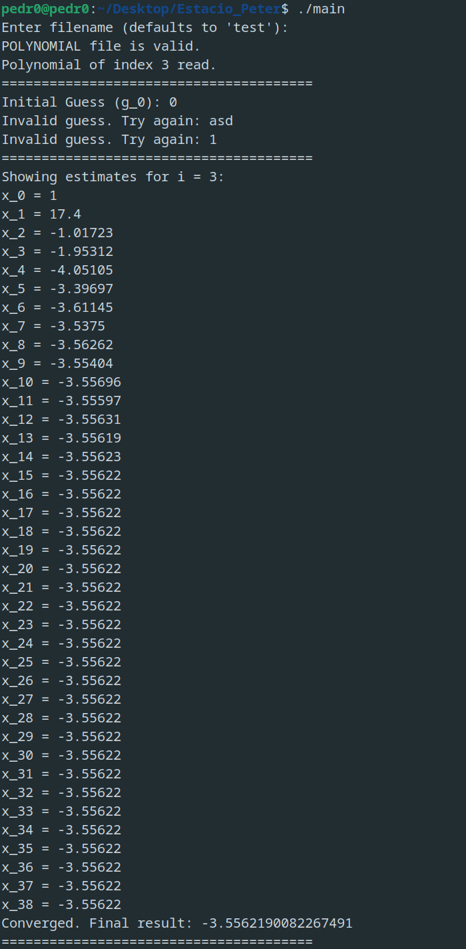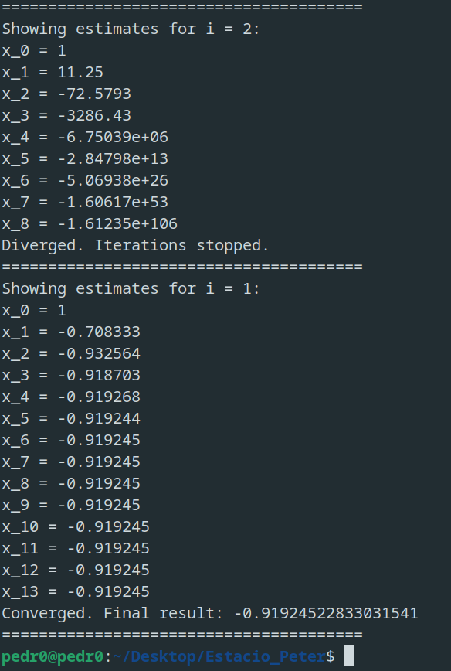
sample screenshots – program executable run and example results
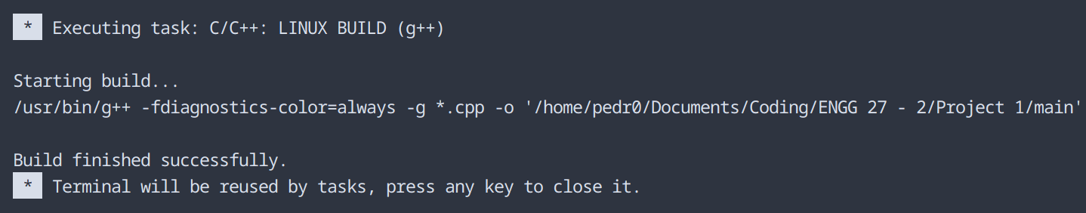
sample screenshot – compilation on Visual Studio Code
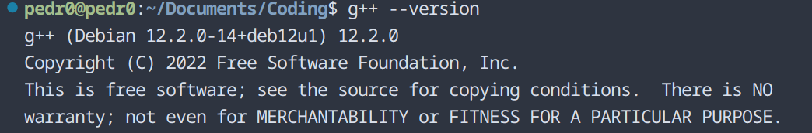
compiler version – g++ (Debian 12.2.0-14+deb12u1) 12.2.0
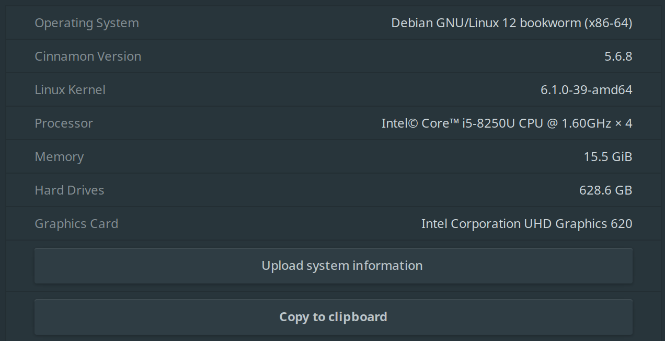
operating system – Debian 12 bookworm, Cinnamon version 5.6.8
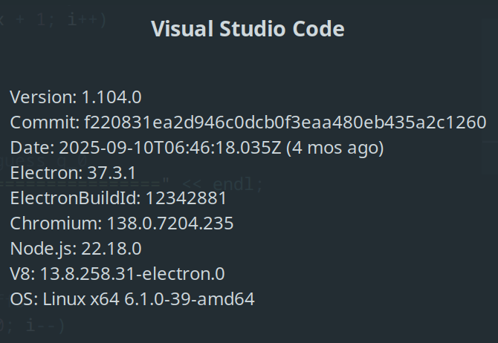
IDE – Visual Studio Code ver 1.104.0

